To be a preferred hub for nurturing computer engineering aspirants through innovative, ethical, value-based technical education, impactful research, and industry collaboration, to become successful professionals contributing for the betterment of society.
Mission Statement of the Department.
To nurture computer engineering professionals by offering Dynamic learning environment that encourages problem-solving using emerging technology, National Education Policy aligned evidence-based technical education, fostering ,innovation, research, and industry–institute collaboration & Holistic, ethical and sustainable development for lifelong success.

Session 2026-2027

Vision:Dream of where you want. | Mission: Means to achieve Vision

Program Educational Objectives of the program (PEO): (broad statements that describe the professional and career accomplishments)
PEO1 | Preparation | P: Preparation | Pep-CL abbreviation pronounce as Pep-si-lL easy to recall
PEO2 | Core Competence | E: Environment  (Learning Environment) | Pep-CL abbreviation pronounce as Pep-si-lL easy to recall
PEO3 | Breadth | P: Professionalism | Pep-CL abbreviation pronounce as Pep-si-lL easy to recall
PEO4 | Professionalism | C: Core Competence | Pep-CL abbreviation pronounce as Pep-si-lL easy to recall
PEO5 | Learning  Environment | L: Breadth (Learning in diverse areas) | Pep-CL abbreviation pronounce as Pep-si-lL easy to recall

Program Outcomes (PO): (statements that describe what a student should be able to do and know by the end of a program)
Keywords of POs:
Engineering knowledge,Problem analysis, Design/development of solutions,Conduct Investigations of Complex Problems, Engineering Tool Usage, The Engineer and The World,Ethics, Individual and Collaborative Team work,Communication, Project Management and Finance, Life-Long Learning

PSO Keywords: Cutting edge technologies, Research

“I am an engineer, and I know how to apply engineering knowledge to investigate, analyse and design solutions to complex problems using tools for entire world following all ethics in a collaborative way with proper management skills throughout my life.” to contribute to the development of cutting-edge technologies and Research.

Integrity: I will adhere to the Laboratory Code of Conduct and ethics in its entirety.

Name and Signature of Student and Date
(Signature and Date in Handwritten)

Name: Ashish Shriram Waghare
Date: /09/2026

To be a preferred hub for nurturing computer engineering aspirants through innovative, ethical, value-based technical education, impactful research, and industry collaboration, to become successful professionals contributing for the betterment of society.
Mission Statement of the Department.
To nurture computer engineering professionals by offering Dynamic learning environment that encourages problem-solving using emerging technology, National Education Policy aligned evidence-based technical education, fostering ,innovation, research, and industry–institute collaboration & Holistic, ethical and sustainable development for lifelong success.

Session | 2024-25 (ODD) | Course Name | Web Technology Lab
Semester | 3 | Course Code | 23CT1301
Roll No | 72 | Name of Student | Yash Nikhad

Practical Number | 6
Course Outcome | - Understand various internet technologies.  - Design the web pages using HTML and CSS.  - Implement the XML technology to store the data.  - Develop the interactive web pages using JavaScript.
Aim | To develop a JavaScript program that models a shopping cart using an array of product objects and demonstrates the use of higher-order functions such as push(), filter(), map(), and reduce().
Problem Definition | To develop a JavaScript program to model a shopping cart using an array of product objects. Each product contains an ID, name, price, and quantity. The program should allow products to be added and removed, extract product names, and calculate the total cart price using JavaScript array methods and higher-order functions.
Theory  (100 words) | An array is a collection of multiple values stored in a single variable, while an object stores data using key-value pairs. JavaScript allows arrays to contain multiple objects, which is useful for representing shopping cart products. The push() method adds a new product to an array, while filter() creates a new array containing elements that satisfy a condition. The map() method creates a new array by applying a function to every element. The reduce() method processes all elements and produces one final value, such as the total cart price. Arrow functions provide a short way to write functions. These methods are examples of higher-order functions in JavaScript.
Procedure and Execution  (100 Words) | Step for Implementation:  - Create a JavaScript file.  - Create an array containing product objects.  - Define a function to add products.  - Use push() to add a new product.  - Define a function to extract product names.  - Use map() to retrieve product names.  - Define a function to calculate the total price.  - Use reduce() to calculate the cart total.  - Use filter() to remove a product.  - Display the cart, product names, and total price and execute the program.
To be a preferred hub for nurturing computer engineering aspirants through innovative, ethical, value-based technical education, impactful research, and industry collaboration, to become successful professionals contributing for the betterment of society.
Mission Statement of the Department.
To nurture computer engineering professionals by offering Dynamic learning environment that encourages problem-solving using emerging technology, National Education Policy aligned evidence-based technical education, fostering ,innovation, research, and industry–institute collaboration & Holistic, ethical and sustainable development for lifelong success.
Code:
index.html:-
<!DOCTYPE html>
<html lang="en">

<head>
<meta charset="UTF-8">
<title>Shopping Cart</title>
<link rel="stylesheet" href="style.css">
</head>

<body>

<h1>Shopping Cart</h1>

<h2>Products</h2>
<div id="products"></div>

<h2>Cart</h2>
<div id="cart"></div>

<h3>Product Names</h3>
<p id="productNames"></p>

<h3>Total Price</h3>
<p id="totalPrice"></p>

<script src="script.js"></script>

</body>

</html>
style.css:-
body {
font-family: Arial;
text-align: center;
}

h1 {
margin-bottom: 20px;
}

#products,
#cart {
margin: 20px auto;
width: 500px;
}

.product {
border: 1px solid black;
padding: 15px;
margin: 10px;
}

button {
padding: 8px 15px;
margin: 5px;
cursor: pointer;
}

#productNames,
#totalPrice {
font-size: 18px;
font-weight: bold;
}

script.js:-
/* Create shopping cart */

let cart = [
{
id: 1,
name: "Laptop",
price: 50000,
quantity: 1
},
{
id: 2,
name: "Mouse",
price: 800,
quantity: 2
},
{
id: 3,
name: "Keyboard",
price: 1500,
quantity: 1
}
];

/* Add operation */

function addToCart(product) {
cart.push(product);
}

/* Remove operation using filter() */

function removeItem(id) {
cart = cart.filter(product => product.id !== id);
}

/* Extract product names using map() */

function getProductNames() {
return cart.map(product => product.name);
}

/* Calculate total using reduce() */

function calculateTotal() {
return cart.reduce(
(total, product) => total + product.price * product.quantity,
0
);
}

/* Display initial cart */

document.getElementById("products").textContent =
JSON.stringify(cart);

/* Add Headphones */

addToCart({
id: 4,
name: "Headphones",
price: 2000,
quantity: 1
});

/* Remove Mouse */

removeItem(2);

/* Display cart */

document.getElementById("cart").textContent =
JSON.stringify(cart);

/* Display product names */

document.getElementById("productNames").textContent =
getProductNames().join(", ");

/* Display total price */

document.getElementById("totalPrice").textContent =
"₹" + calculateTotal();

/* Display output in console */

console.log("Initial Cart:");
console.log(cart);

console.log("\nCart after adding Headphones:");
console.log(cart);

console.log("\nCart after removing Mouse:");
console.log(cart);

console.log("\nProduct Names:");
console.log(getProductNames());

console.log("\nTotal Price: ₹" + calculateTotal());

Output:
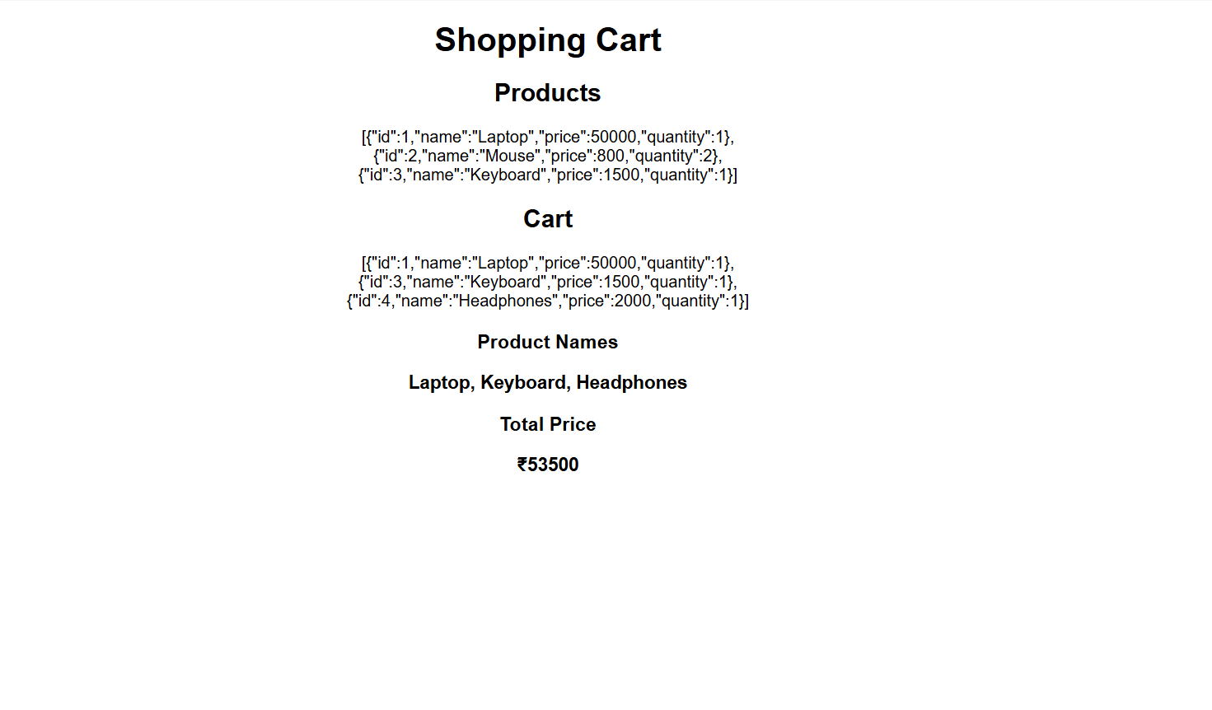

Output Analysis | The Shopping Cart application is displayed successfully in the browser. The output shows the initial products and the updated cart after adding Headphones and removing Mouse. The map() function successfully extracts the product names as Laptop, Keyboard, Headphones. The reduce() function correctly calculates the total cart price as ₹53,500. This confirms that the required array operations and higher-order functions are working correctly.
Link of student Github profile where lab assignment has been uploaded | https://github.com/YashNikhad
Conclusion | Thus, a JavaScript-based shopping cart was successfully developed using an array of product objects. The push(), filter(), map(), and reduce() methods were successfully used to add products, remove products, extract product names, and calculate the total cart price.
Plag Report (Similarity index < 12%) | The practical was prepared using the concepts and instructions provided for the experiment. The code and written content were implemented in the required format, with the theory and explanations presented in an appropriate form. The work was reviewed to avoid unnecessary copying from external sources.
Date | /09/2026

